**Teacher: Gitpod**

**Email: https://nextflowio-training-c4imldg7dg8.ws-eu116.gitpod.io/**

Nextflow using Gitpod

___

# Notes

## Introduction: What is a Gitpod?

Gitpod is a **cloud-based development environment platform** that **automates the setup and management** of development environments. It allows developers to **start coding instantly** by providing **pre-configured, ready-to-code environments** directly in their web browsers. Here’s a closer look at what Gitpod is and why it’s beneficial:

* **Automated Environments**: Gitpod automates the provisioning of development environments, ensuring that **every developer gets the same setup without manual configuration**.
* **Browser-Based IDE**: It provides a **VS Code-like interface** in the browser, allowing you to **code from anywhere** without needing to install software locally.
* **Prebuilt Workspaces**: Gitpod **continuously builds your Git branches like a CI/CD server**, so your environment is always **up-to-date**.
* **Integration with Git Platforms**: It integrates **seamlessly with GitHub, GitLab, and Bitbucket**, making it **easy to start coding** on any project.

## Why Use Gitpod?

* **Consistency**: Ensures that all team members have the same development environment, reducing “it works on my machine” issues.
* **Speed**: Developers can start coding immediately without spending time on environment setup. This is particularly useful for onboarding new team members.
* **Flexibility**: You can access your development environment from any device with a web browser, making remote work and collaboration easier.
* **Scalability**: Gitpod can handle multiple environments and large projects, making it suitable for both small teams and large enterprises.
* **Security**: Isolated environments and integration with identity providers ensure that your code and data remain secure.

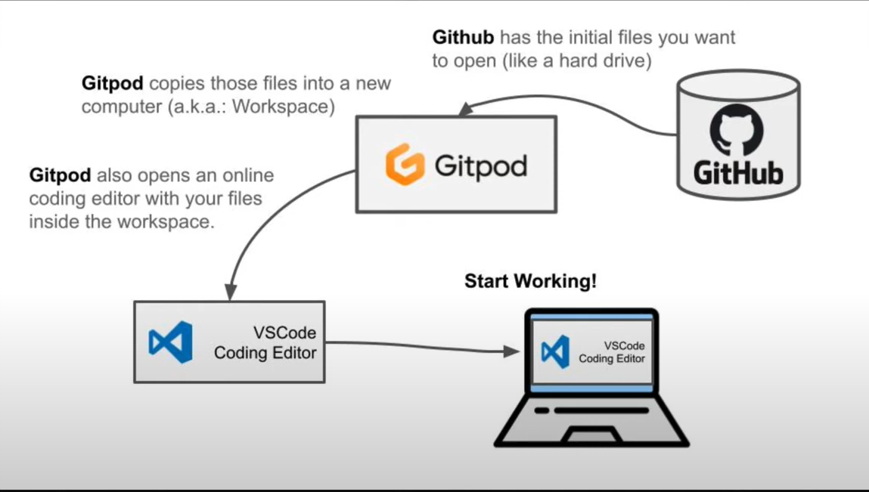

This image depicts how Gitpod works.

# Introduction: Nextflow

Nextflow is a workflow management system that simplifies the creation and execution of complex data analysis pipelines. It is particularly popular in bioinformatics for its ability to handle large-scale data processing.

To install Nextflow, you need Java 8 or later. You can install Nextflow using the following command:

*curl -s https://get.nextflow.io | bash*

## Basic Concepts

* **Processes**: The basic building blocks of a Nextflow pipeline. Each process defines a task that can be executed.
* **Channels**: Used to connect processes and pass data between them.
* **Scripts**: Nextflow scripts are written in a domain-specific language based on Groovy.

Tree command - creates directory structure and contents in a readable form

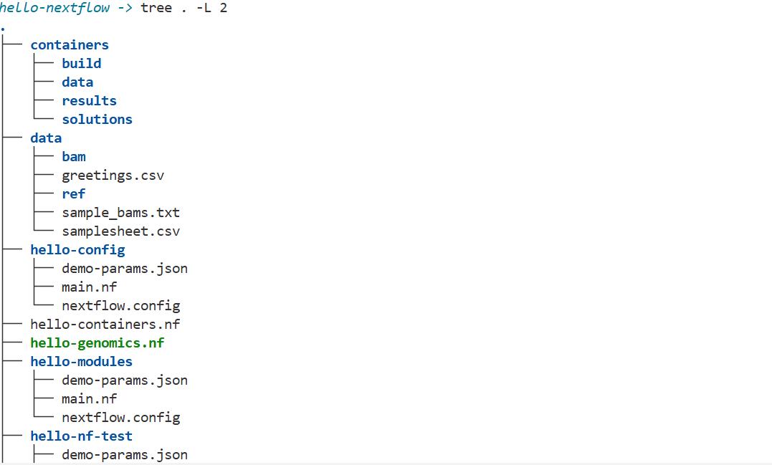

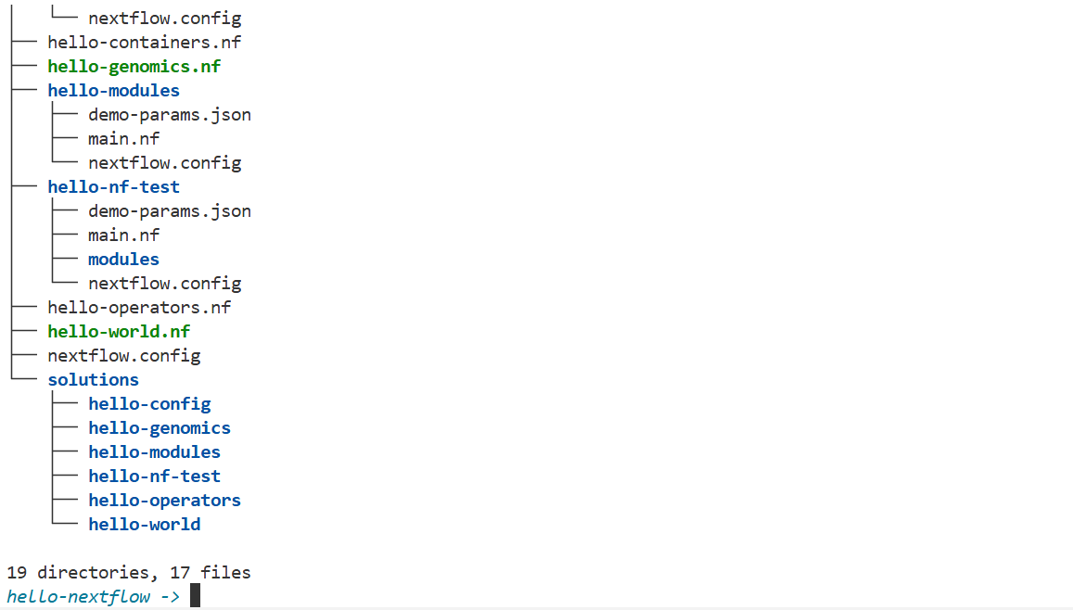

***“tree . -L 2”*** is the command

.nf files are workflow scripts

Hello -* are directories used

Nextflow.config - configuration file

Data directory - stores input data

Solutions directory - completed workflow

If u ever move out of nextflow directory, use the below command to get back into it

“***cd /workspace/gitpod/hello-nextflow***”

# Part 1: Hello World

A "Hello, World!" is a minimalist example that is meant to demonstrate the basic syntax and structure of a programming language or software framework.

In this first part of the Hello Nextflow training course, we ease into the topic with a very simple domain-agnostic Hello World example, which we'll progressively build up to demonstrate the usage of foundational Nextflow logic and components.

Make the terminal say hello

***hello-nextflow -> echo 'Hello World!'***

Output:

Hello World!

Now make it write the text output to a file

***“hello-nextflow -> echo 'Hello World!' > output.txt”***

***“hello-nextflow -> ls”***

***“hello-nextflow -> cat output.txt”***

Output

containers hello-config hello-genomics.nf hello-nf-test hello-world.nf output.txt

data hello-containers.nf hello-modules hello-operators.nf nextflow.config solutions

Hello World!

## 